[**3.8 Use complex processes to develop a digital technologies outcome**](https://www.nzqa.govt.nz/nqfdocs/ncea-resource/achievements/2019/as91907.pdf)

|  |  |  |  |
| --- | --- | --- | --- |
| **Achievement Standard** | **Achievement** | **Achievement with Merit** | **Achievement with Excellence** |
| **3.8**  **(6 credits)** | Use complex processes to develop a digital technologies outcome | Use complex processes to develop an informed digital technologies outcome | Use complex processes to develop a refined digital technologies outcome |

|  |  |  |
| --- | --- | --- |
| **Achieved** | ✓ | **Comments** |
| Use recognised and appropriate [project management tools and techniques](https://docs.google.com/document/d/1bOHCQj7juhB9ux75BIy5x-PUjjixQtotY0dBSLvwXsk/preview#bookmark=id.9s67oa6vm34) to manage the development |  |  |
| Use recognised and appropriate techniques to plan the development |  |  |
| Outcome is decomposed into smaller components |  |  |
| Version control tool(s) utilised |  |  |
| Components of outcome trialled |  |  |
| Outcome is tested to ensure it functions as intended |  |  |
| [Relevant implication(s)](https://docs.google.com/document/d/1bOHCQj7juhB9ux75BIy5x-PUjjixQtotY0dBSLvwXsk/preview#bookmark=id.rqkyku37fesf) addressed |  |  |
| **Merit** |  |  |
| Effectively use project management tools and techniques to manage development, feedback and/or collaborative processes |  |  |
| Effectively trial multiple components and/or techniques |  |  |
| Effectively use information from testing and trialling to improve functionality |  |  |
| Evidence of appropriate use of information from testing and trialling to improve functionality of outcome |  |  |
| Effective use of project management and version control tool(s) |  |  |
| **Excellence** |  |  |
| Synthesised information gained from the planning, testing and trialling of components |  |  |
| Discuss how the above information led to the development of a high-quality digital technologies outcome. |  |  |

|  |  |  |  |  |  |  |
| --- | --- | --- | --- | --- | --- | --- |
| **Overall Grade:** | **Achieved** |  | **Merit** |  | **Excellence** |  |

**Standard 3.8**

**Target Audience**

Lonely gamers and anime enthusiasts who have reasonable knowledge in games/otaku culture.

**Project management** was done with Trello

<https://trello.com/b/6y926mZp/team-goal-tracker>

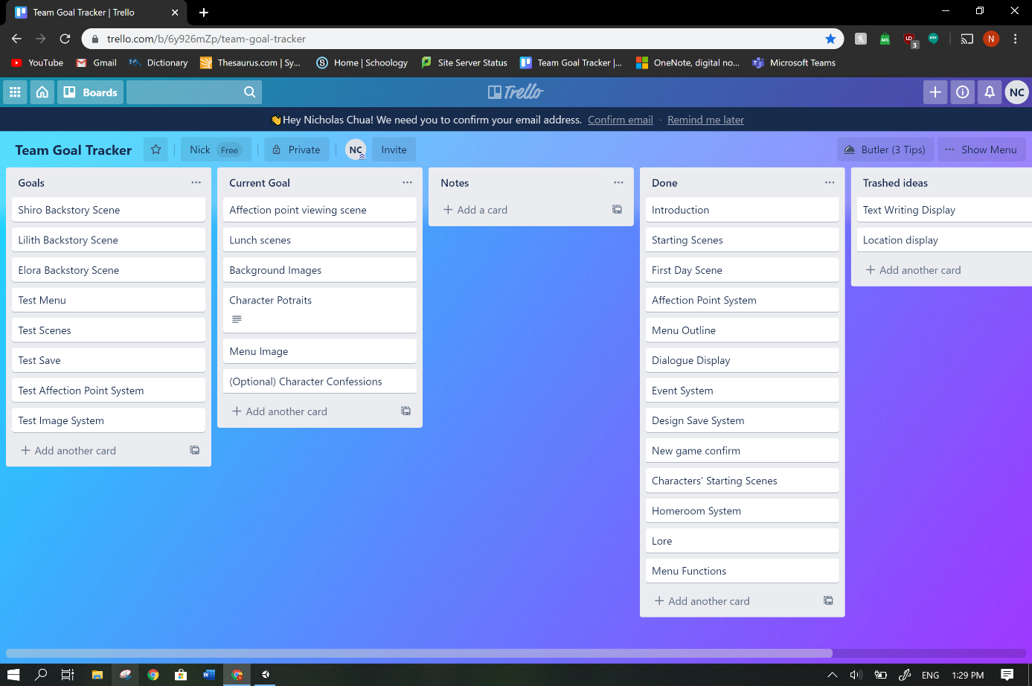

**Planning**

**Aim:** Create a dating simulator/visual novel game to entertain the user and make them feel less lonely.

**Gameplay Flow**

Menu

New game

Choose your sex

Introduction

First day

Homeroom

Talk to heroines

Lunch

Talk to heroines

Cycle starts again from Homeroom

**Menu choices:**

Newgame: Deletes old save file and creates a new one, beginning the game again from the beginning.

Continue: Returns user to the beginning of the last scene they were in.

Lore (added later on): Allows the user to read the extensive lore.

Affection (added later on): Allows the user to view affection points.

Go to text transcript

**Feedback and Changes**

“You could probably reverse google search the photos.” **-Veteran Coder Aidan**

To avoid the potential issue of getting sued, I have edited the background sprites to less resemble the original photos they were based off of and changed things to fit the in-game lore.

|  |  |  |
| --- | --- | --- |
| Original | Pixelized | Edited |
| Japanese Classroom" Model #AD#3D Classroom#Japanese#quot#Interior ... |  |  |

Original image from <https://www.assetstore.unity3d.com/#!/content/71392?aid=1101l3b93&pubref=3D>

“Maybe you could make a lore page for it like ‘Mass Effect’.” **-Veteran Coder Aidan**

A lore scene with its own special page navigation was added to the menu and expanded upon.

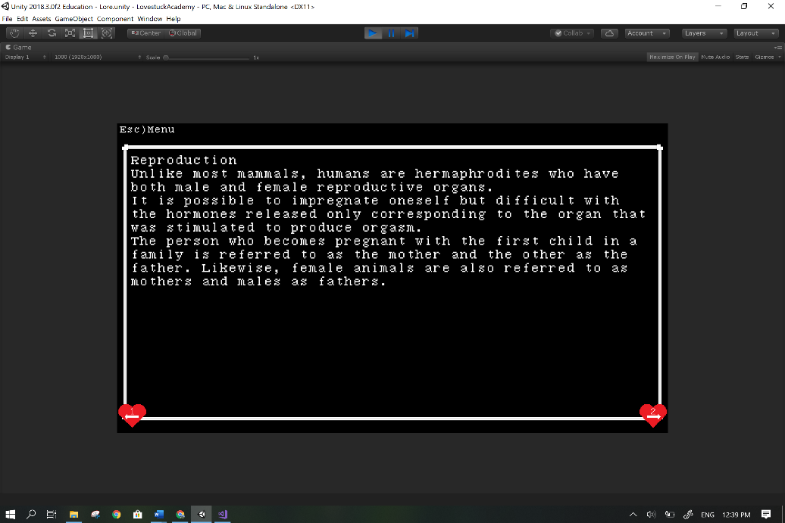

“I went to character affection menu and I couldn’t get back to main menu.” **-Man of Taste Fred**

Wrote code to return to the menu by pressing the esc key which no longer traps the user in the character affection menu, improving user satisfaction.

“What’s the next button for the text, Spacebar? 1?” **-Man of Taste Fred**

Overhauled the system to progress through pages with space instead of one which means removing all the hearts with one on them, adding the instruction at the beginning and altering most scripts as well as retesting it. This improves the user’s experience and makes the controls more intuitive to people with experience playing games on computer keyboards.

“I CAN’T KEEP TO MYSELF WRYYYY.” (context = option in the game) **-Man of Taste Fred**

Code for the option did not exist at the time and so it was written.

“Ketchup girl is also bugged’” **-Man of Taste Fred**

Childed the image system to the text system so that images no longer covers the text boxes in that scene and the others which suffered from the same issue.

“Hermaphrodites?” **-Just Really Cool Hannah**

“So it’s not sexist.” **-Me**

“’With the appearance of a woman.’” **-Just Really Cool Hannah**

Removed the text “With the appearance of a woman.” To avoid a feeling of immediate discrimination for women and also so no one can use that quote against me.

“Whirling sounds kinda violent for the atmosphere.” **-Literary Legend Lisa**

Changed dialogue text from “whirling” to “gently flowing.”

“Why do people keep saying Eli? It’s Ellie.”**-Me**

“Because that’s how you say it and Ellie is ‘E’ ‘L’ ‘L’ ‘I’ ‘E’.”

Changed all “Eli” to “Ellie” which keeps the consistency with character’s names being female or unisex.

“If you make a boss in your game, I’ll consider adding one to mine.”**-Veteran Coder Aidan**

A **boss battle** was added to the game as a lunch event where you play a game.

Boss Battle Initial Plan:

The battle involves selecting pre-given choices using the number keys and each choice goes into a new scene. The enemy is a rock that fires lasers at you every 5 seconds, decreasing your health. You have a choice of 4 options which might damage the rock or make you take damage.

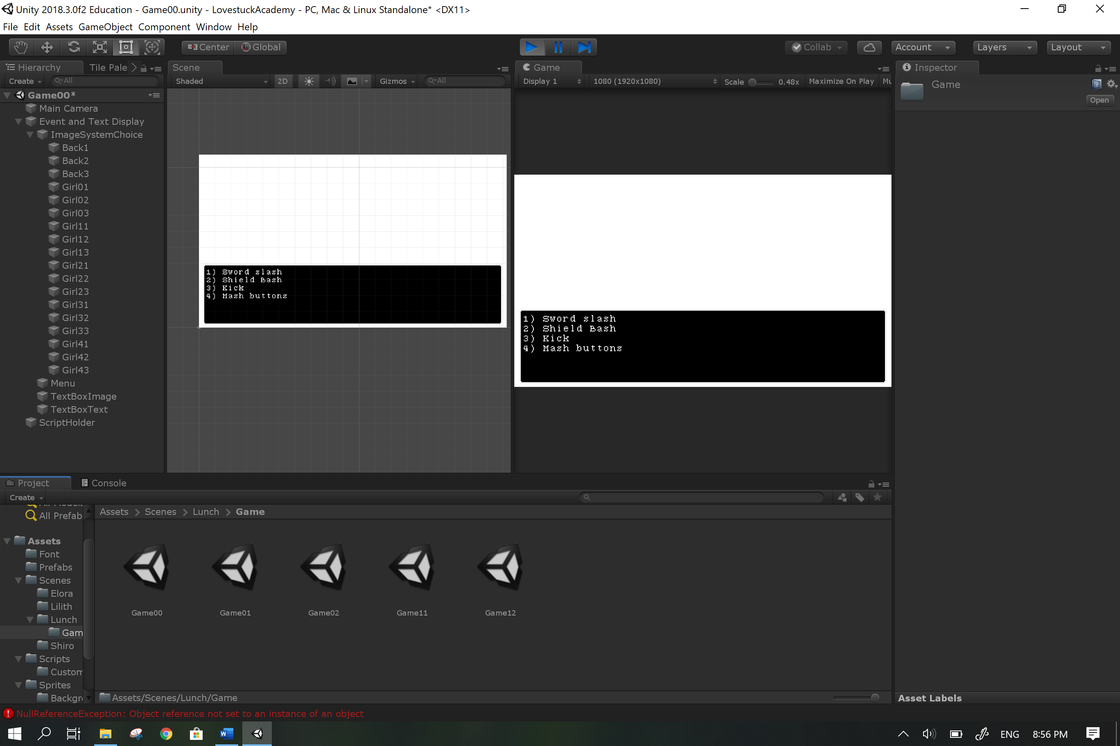

Final Outcome: Due to the large number of scenes that would need to be created for all the possible branching choices, I decided to only use one scene with a new script that generates a random number to determine the choices shown and their impact when chosen as opposed to multiple scenes which would each provide one set of choices and impacts. The number of choices has been changed to 3 to reduce the workload. All other aspects of the initial plan was carried out.

All testers (10 people in total) tried to use the cursor to click the buttons on the menu so the cursor was hidden to prevent any future confusion.

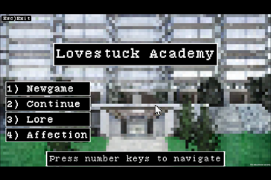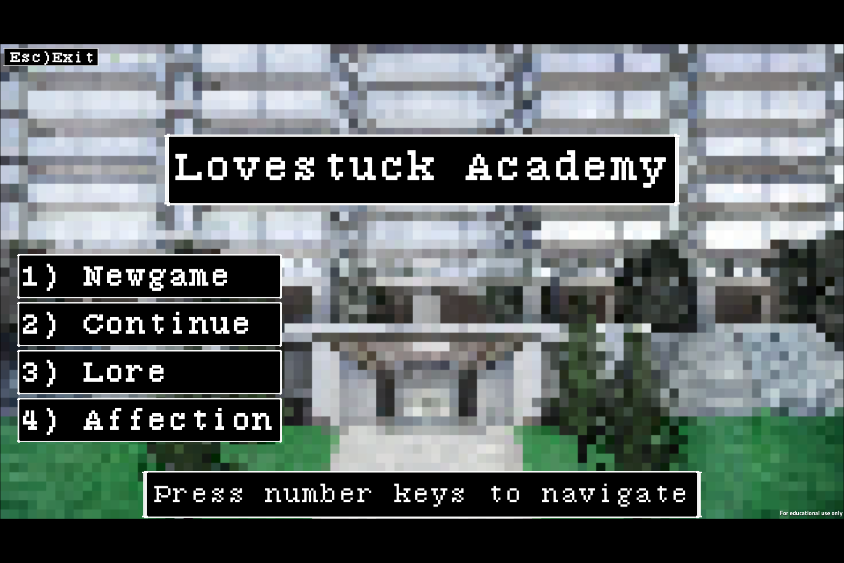

Before After

All testers were unsure how to proceed after making their first choice during a choice event so instructions were added after the first player choice to ease the game experience.

**General Components Feedback**

All testers were mostly satisfied with the changing of text.

All testers were fond of the images and had no issue with the image changing system.

All testers found the choice events satisfying.

Overall testers were entertained and distracted (forgot about their loneliness) so the aim was met.

**Personal Changes**

Text system was initially made using a queue and array based off of the system from <https://www.youtube.com/watch?v=_nRzoTzeyxU> where a queue would load elements from an array and then be dequeued to return the text to the text display but the system could not function as so was replaced with another system built solely on arrays which is simpler and functions well.

The sudden changes in scenes felt jarring so extra text was added in between scenes to ease the flow of gameplay.

**Proof of Multiple Iterations**

<https://github.com/NickTheNicker/LovestuckAcademy>

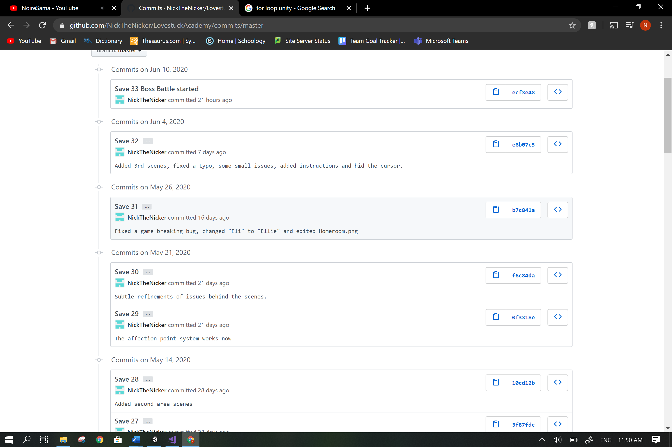

**Save 8**

Scenes lack images, text boxes can’t display text and very little code has been written.

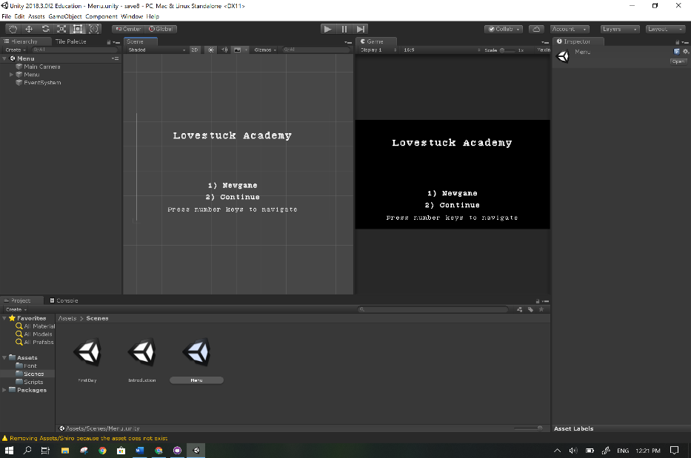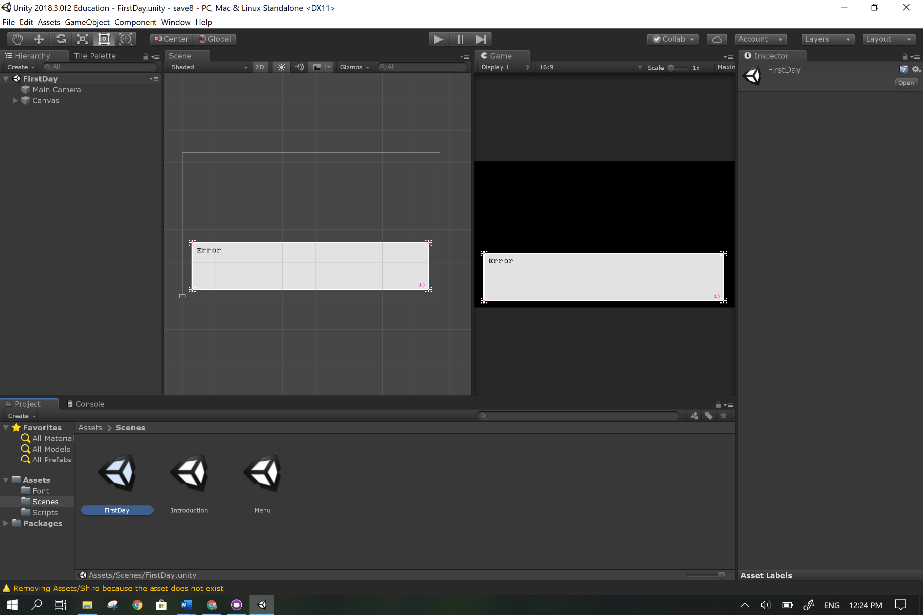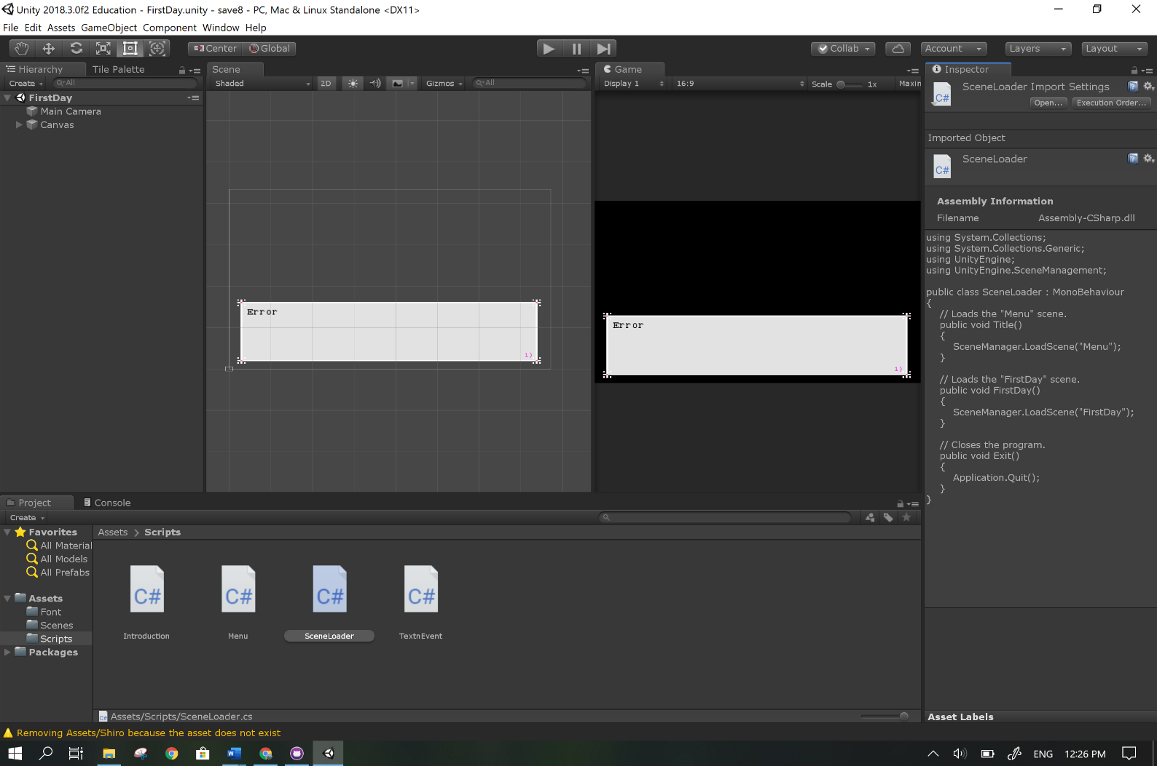

**Save 18**

Scenes still lack images; text boxes display text and can switch pages by pressing the 1 key. Code is complex: a large number and variety of values are used in the many methods that access components and other scripts. Errors are extremely common.

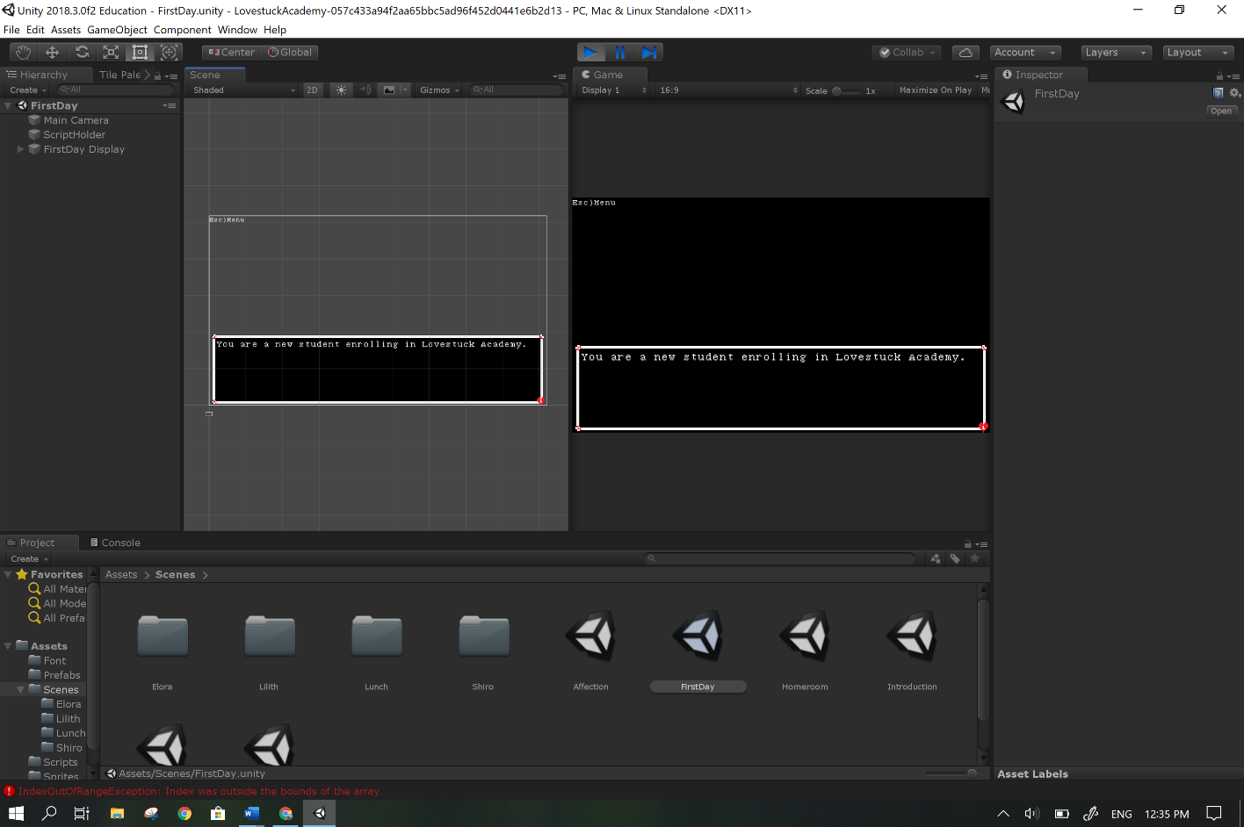

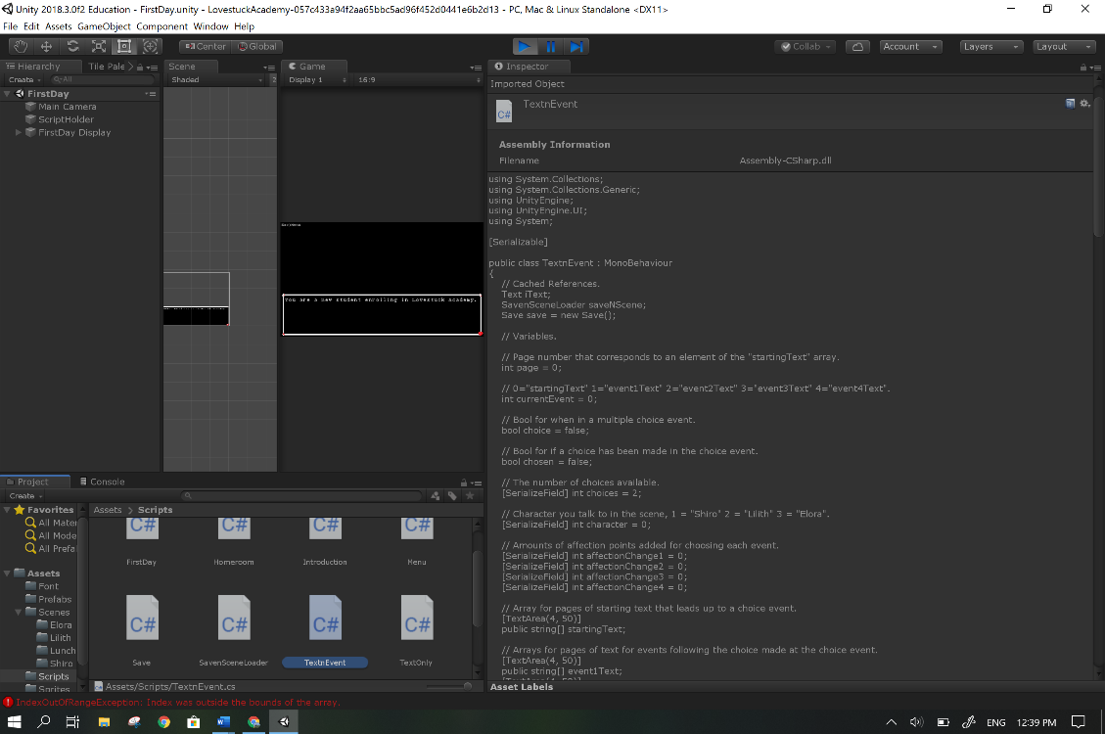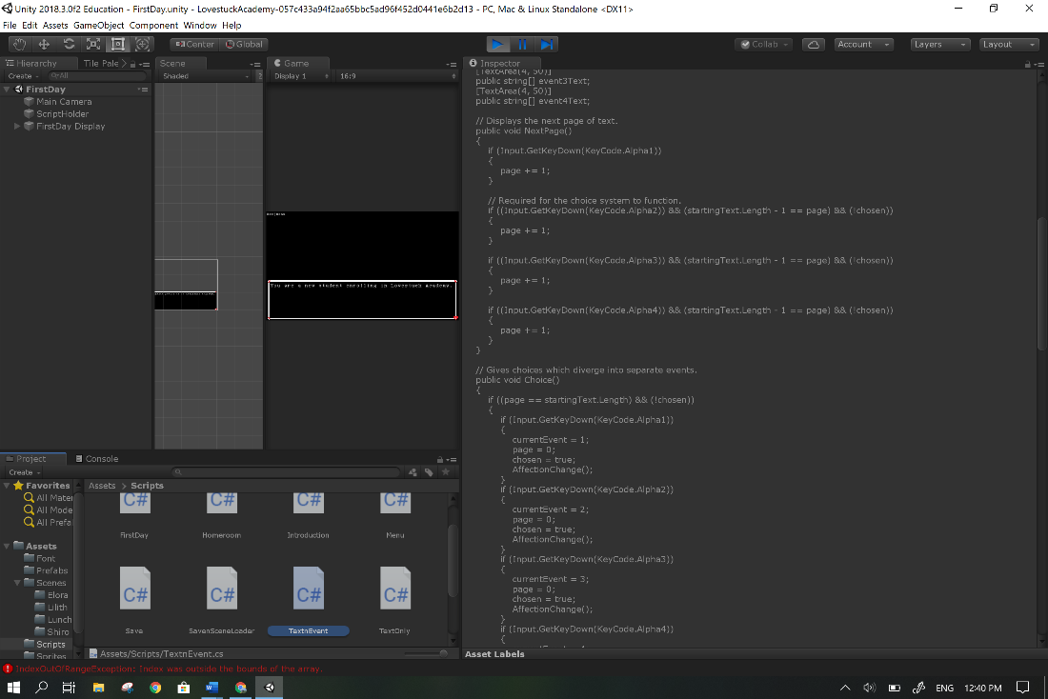

**Save 30**

Scenes have images, save system functions and code is arranged and detailed with comments and complete with no errors. The program now carries out its purpose to entertain the user more efficiently.

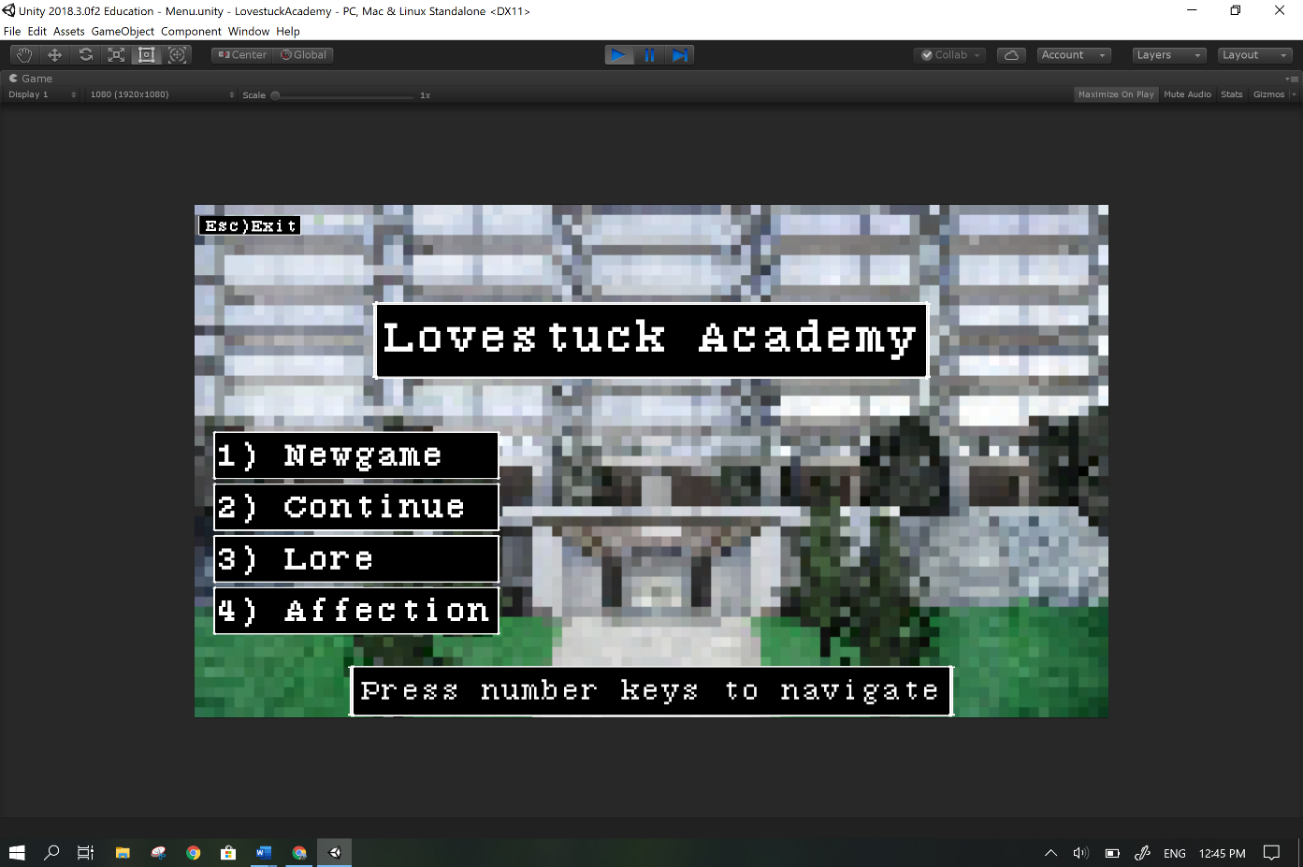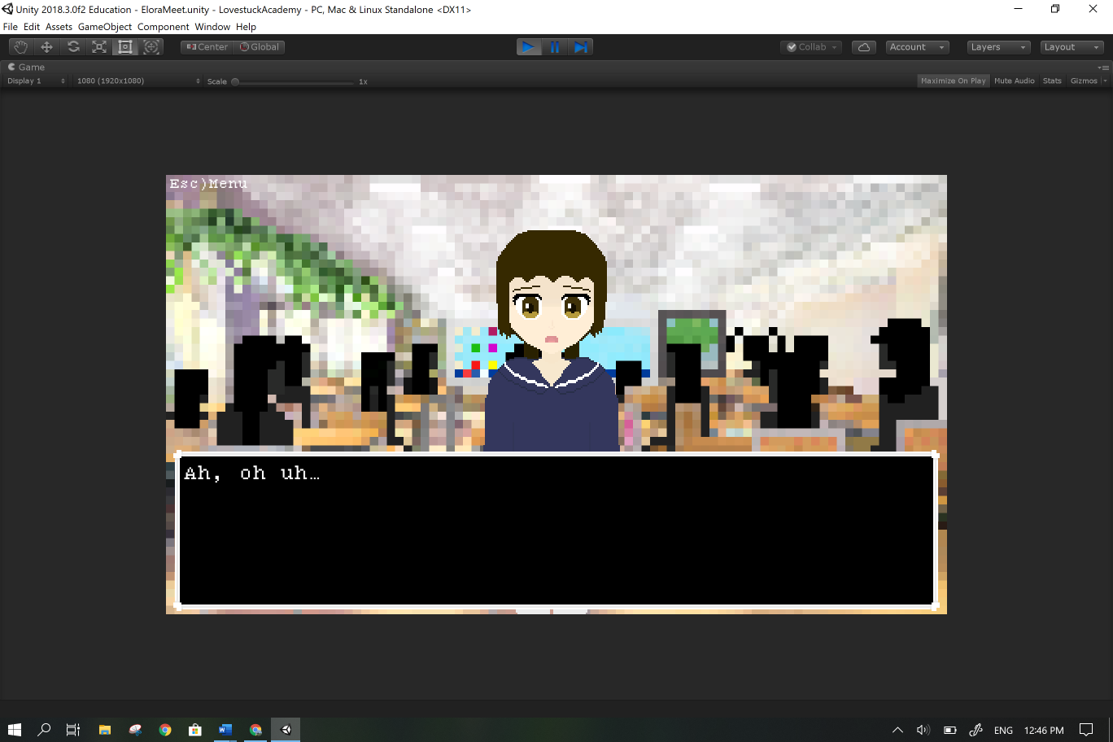

**Relevant implications**

**Social:**

Age restriction of 16+ as some scenes talk about sexual intercourse or sexual organs.

While the nature of the game as a dating simulator might create unrealistic expectations in relationships given the speed at which the heroines get attached to the character, it is expected for the user to distinguish between game and reality when making decisions; therefore, I as the creator am not in any way responsible for any actions the user takes under the influence of the game.

A page of lore hints that every character is Christian and speaks positively about the religion which may offend certain users of different religions but does not directly nor purposely attack any religion.

Every character is a hermaphrodite with female appearances that potentially ostracises female players but less than other dating simulators which have female only love interests.

Everyone is a hermaphrodite because that justifies that this game is not entirely biased towards men but also explores the idea as a side focus to give a new perspective on our own world and what sex and gender differences mean when looking at a world where everyone has the same sex and gender: how do people view animals with two sexes, how would less barriers between people understanding each other feel like or how you refer to parents of the same sex?

The characters have feminine appearances and refer to each other using female pronouns which is catered towards a male audience; however, men have a greater disdain towards any form of intimacy with the same sex but women are more comfortable with that intimacy: girl’s would be more likely to share their feelings and touch each other as a way to show affection.

The game has been noted to be rather esoteric with its references and jokes, that is completely intentional.

Cultural: Nothing in the game should offend any and all cultures but if anything does it was never intended to.

**Legal/Intellectual property:**

Use of the program is completely legal, the user will not break any laws using the program.

Users are free to show footage of the game and borrow assets but must credit me for the sprites and cannot say it is their own work.

All character sprites were drawn by me and bear little to no resemblance to the things I based them off so it would be impossible to copyright claim them.

Background sprites were inspired by real images and designs but altered significantly.

All scripts in the “scripts” folder were written by me except for the referenced code by Josh Browne and Aidan Diprose.

The free for commercial use font was ‘**7:12 Serif Font’** by Christian Munk <https://christianmunk.1001fonts.com/>

**Ethical:**

The program does not harm users, animals and property directly or directly encourage users to harm themselves, people, animals and property.

**Privacy:**

The game does not ask for any personal information from the user. The game has no way of recording anything on the user’s computer or through it (cameras or microphones).

**Accessibility:**

Usability/Functionality: The game is meant to be played for recreational use, it is the user’s opinion on how well it carries out it’s purpose but it functions as intended with no observed bugs remaining and improved after user feedback.

**Aesthetics:**

The pixel style of the game gives it a retro feel.

No nudity nor partial nudity.

**Sustainability and Future proofing:**

The code is extensively commented and structured so that all methods and variables are easily understood by whoever wishes to maintain the code. Comments detail the function of the code and the structure ensures a logical flow of information.

**End-user considerations:**

Game is not suitable for audiences under 16 due to the topics discussed by in-game characters, graphic descriptions and sensitive topics.

Controls shown when needed and if not shown, follow standard game control conventions. (Space bar to progress through text.)

**Health and safety:**

The game is 1 hour long but through repeated playthroughs over long periods of time (3 hours or more) the user might suffer from the following conditions:

* sore eyes
* sore wrists
* neck pain
* back pain

The user is also advised not to stare too closely at the screen as that will be bad for their eyes.

**I am not in anyway responsible for the problems stated above.**

**Text Transcript**